Standard Format for Paper Submission to ICAST 2024
(Research Session)

Taro Kumamoto* and Hanako Hinokuni
Graduate School of Science and Technology, Kumamoto University
(Note: * should be placed at the presenter’s name as shown above.)

Abstract- The abstract is limited to 150 words and cannot contain equations, figures, tables, or references. It should concisely state what was done, how it was done, principal results, and their significance.

Index Terms- The author shall provide up to 5 keywords to help identify the major topics of the paper.

Introduction
THIS document provides an example of the desired layout for a paper. It contains information regarding desktop publishing format, type sizes, and typefaces. Style rules are provided that explain how to handle equations, figures, tables. Sections are also devoted to the preparation of references.

Paper Preparation
Please use automatic hyphenation and check your spelling. Additionally, be sure your sentences are complete and that there is continuity within your paragraphs. Check the numbering of your graphics (figures and tables) and make sure that all appropriate references are included.

Template
This document may be used as a template for preparing your paper. When you open the file, select "Page Layout" from the “View” menu (View | Page Layout). You may then type over sections of the document, cut and paste into it (Edit | Paste Special | Unformatted Text), and/or use markup styles. The pull-down style menu is at the left of the Formatting Toolbar at the top of your Word window (for example, the style at this point in the document is “Text”). Highlight a section that you want to designate with a certain style, then select the appropriate name on the style menu.

Format
If you choose not to use this document as a template, prepare your paper in single-spaced, double-column format, on paper 21.6×27.9 centimeters. Set top and bottom margins to 16.9 millimeters and left and right margins to about 16.9 millimeters. Do not violate margins (i.e., text, tables, figures, and equations may not extend into the margins). The column width is 88.9 millimeters. The space between the two columns is 4.2 millimeters. Paragraph indentation is 4.2 millimeters. Use full justification. Use either one or two spaces between sections, and between text and tables or figures, to adjust the column length.

Typefaces and Sizes
Please use a proportional serif typeface such as Times Roman or Times New Roman and embed all fonts. Table I provides samples of the appropriate type sizes and styles to use.

TABLE I
Samples of Times Roman Type Sizes and Styles Used for Formatting a Paper

Font Size | Purpose in Paper | Special Appearance
8 | All captions, table text, figure text, subscript, references
9 | Abstract, keywords
10 | Body text, equations | Section Title  Subheading
11 | Author Name
20 | Title | Title

Section Headings
A primary section heading is enumerated by a Roman numeral followed by a period and is centered above the text. A primary heading should be in capital letters.
A secondary section heading is enumerated by a capital letter followed by a period and is flush left above the section. The first letter of each important word is capitalized and the heading is italicized.

Figures and Tables
Figure axis labels are often a source of confusion. Try to use words rather than symbols. As an example, write the quantity “Time”, or “Time T” not just “T”. Put units in parentheses. Do not label axes only with units. As in Fig. 1, write “Time (hour)”, not just “hour”. Large figures and tables may span both columns, but may not extend into the page margins. Figure captions should be below the figures; table captions should be above the tables. Do not put captions in “text boxes” linked to the figures. Do not put borders around your figures.
All figures and tables must be in place in the text near, but not before, where they are first mentioned. Use the abbreviation "Fig. 1," even at the beginning of a sentence.

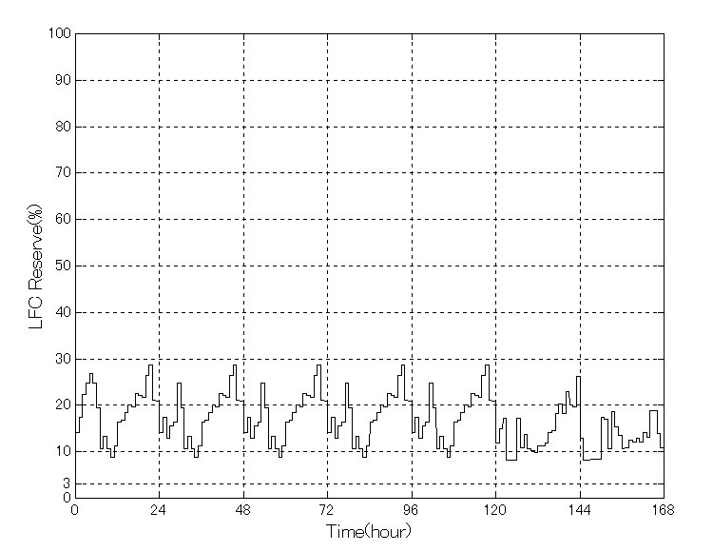

Fig. 1. Spinning reserve for LFC units (Note that "Fig." is abbreviated and there is a period after the figure number followed by two spaces.)

Numbering
Number reference citations consecutively in square brackets [1]. The sentence punctuation follows the brackets [2]. Multiple references [2], [3] are each numbered with separate brackets [1]-[3]. Refer simply to the reference number, as in [3]. Do not use "Ref. [3]" or "reference [3]" except at the beginning of a sentence: "Reference [3] shows…."
Check that all figures and tables are numbered correctly. Use arabic numerals for figures and Roman numerals for tables.

Abbreviations
Define less common abbreviation the first time they are used in the text, even after they have been defined in the abstract. Abbreviations such as SI, MKS, CGS, ac, dc, and rms do not have to be defined. Do not use abbreviations in the title unless they are unavoidable.

Equations
Use Microsoft Equation Editor for all math objects in your paper.
To make your equations more compact, you may use the solidus ( / ), the exp function, or appropriate exponents. Italicize Roman symbols for quantities and variables, but not Greek symbols. Use a long dash rather than a hyphen for a minus sign. Use parentheses to avoid ambiguities in denominators.
Number equations consecutively with equation numbers in parentheses flush with the right margin, as in (1). Be sure that the symbols in your equation have been defined before the equation appears or immediately following.
$E_{e}=\frac{I_{\text{sc}}}{I_{\text{sco}}\left\{ 1+α_{I_{\text{sc}}}(T_{c}−T_{o}) \right\}}$ (1)

$δ(T_{c})=\frac{n k ( T_{c}+\text{275}\text{.}\text{15} )}{q}$ (2)

where
n: empirically determined diode factor for each cell
k: Boltzmann’s constant, 1.38066.10⁻²³ J/K
q: elementary charge, 1.60218.10⁻¹⁹ coulomb

Use "(1)," not "Eq. (1)" or "equation (1)," except at the beginning of a sentence: "Equation (1) is .…"

Acknowledgment
The authors gratefully acknowledge the contributions of Dr. Engin Karatepe for valuable comments on this work and Mr. Zhang Wei for helping in the real-time simulation

References
References are important to the reader. Therefore, each citation must be complete and correct. References should be readily available publications. Give all authors' names; do not use et al.
Samples of the correct formats for several types of references are given below.

- Y. Sukamongkol, S. Chungpaibulpatana, and W. Ongsaku, “A simulation model for predicting the performance of a solar photovoltaic system with alternating current loads,” Renewable Energy 27 (2002), pp. 237–258.
- D.J. Flood, “Advanced space photovoltaic technology: Applications to telecommunication systems,” in Proc. 1997 International Telecommunication Energy Conf., pp. 647-651.
- S.M. Alghuwainem, “A close-form solution for the maximum-power operating point of a solar cell array,” Solar Energy Materials and Solar Cells 46 (1997), pp. 249-257.
- T. Hiyama, and K. Kitabayashi, “Neural network based estimation of maximum power generation from PV module using environmental information,” IEEE Trans. Energy Conversion, vol.12, pp.241-247, Sept. 1997.
- T.Hiyama, “Fuzzy logic power system stabilizer using polar information,” in Electric Power Applications of Fuzzy Systems, M.E. El-Hawary, Ed. New York: IEEE Press, 1998, pp. 149-177.

